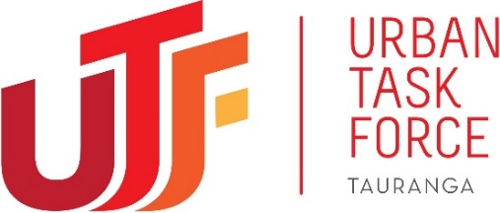

$110+ million of Government Funds Missing In Action Says New Tauranga Lobby Group

TAURANGA, 8 July 2021: Influential new property leadership group, the Urban Task Force (UTF) want urgent answers about where over $110 million of Government funds provided to the Tauranga City Council has ended up.
The funding was provided for a water treatment plant in 2017, yet despite this huge cash injection the Council has raised development contributions on new housing projects to cover the cost of the yet-to-be-built plant.
Development contribution costs will rise by $7,500 per house from next month (1 August 2021) and by a further $10,500 from February next year and will apply to building consents for new residential and non-residential developments.

UTF Chairman Scott Adams questions the Council’s justification for the cost increase for new homes at a time in which housing affordability is already at crisis point.

“Our city is in the midst of a housing crisis with a well-publicised shortage of homes and spiralling house prices. If the Council is to add more pressure to the construction industry, we’d at least like to understand the reasoning behind the increased costs,” he says.
“We’re really concerned about the lack of transparency and the speed of this decision. The Council states that development contribution increases will cover the cost of the Waiari Water Treatment Plant, but we believe this facility has already been paid for,” says Adams.
The UTF is an incorporated society formed earlier this year to provide powerful, knowledgeable leadership and the benefits of years of experience to Tauranga city’s local authorities. Members comprise of some of the city’s most influential developers, investors, professionals and iwi deeply concerned about the direction the city is taking.

“Decades of mismanagement has led to poor planning, under-investment and toxic relationships with external stakeholders,” says Adams.
“We believe that a new leadership model of collaborative, innovative thinking across central Government, local Government, iwi and the private sector is the only way to resolve the city’s numerous challenges,” he says.
The UTF recently presented their verbal submission for the Council’s 2021-2031 Long Term Plan, one of several submissions they have planned to contribute to discussions about the future of the city.

They noted the Waiari Water Treatment Plant received funding in 2017 from the Government’s Housing Infrastructure Fund as part of a 10-year interest free $230 million government loan, to support infrastructure providing additional water and wastewater for an additional 35,000 homes. Of the $114 million set aside for the plant, it is uncertain what, if anything, has been spent.
“If the costs of the water treatment plant have gone up, ratepayers deserve to know,” says Adams.
“These important water infrastructure costs have long been planned and funded, and we have no line of sight to what appears to be a major cost blowout. Asking families building new homes in 2021 to pay for infrastructure that the Council apparently already has funding for seems disingenuous. It appears we aren’t making the most of central government funding allocated to our region.”

ENDS

For more information about the Urban Task Force see: https://urbantaskforce.co.nz/
For more images, information or interviews on this news release contact:
Sarah Cook
Village PR & Marketing
sarah@villagenz.com
021 125 2745

